

|  |  |
| --- | --- |
|  |  |

|  |
| --- |
| **Assignment 2**  **Total Marks: 50**  **Instructions:**   1. **This assignment is consisted of different sections as shown in the image. You are required to understand each section first.** 2. **Each section has separate marks.** 3. **You are required to make different divs and then complete the exam within the given time.** 4. **You should submit a zip file (soft copy).** 5. **Code should be easy to read.** 6. **UI should be user friendly** |

**Question 1:**

You are required to convert the image file provided into HTML code an submit the zip file. Your .zip file should have all images.

**Marking Criteria:**

1. Each section has separate marks.
2. Make the website as per your understanding.
3. Code should be properly formatted
4. Proper naming conventions should be followed
5. Web page should exactly look similar to the Image provided.
6. You are only allowed to use external CSS.

Marks Division:

Time Allowed: 10 Minutes.

Total Marks: 5

**Section 1: Navigation Bar.**



Time Allowed: 10 Minutes.

Total Marks: 5

**Section 2: Banner.**

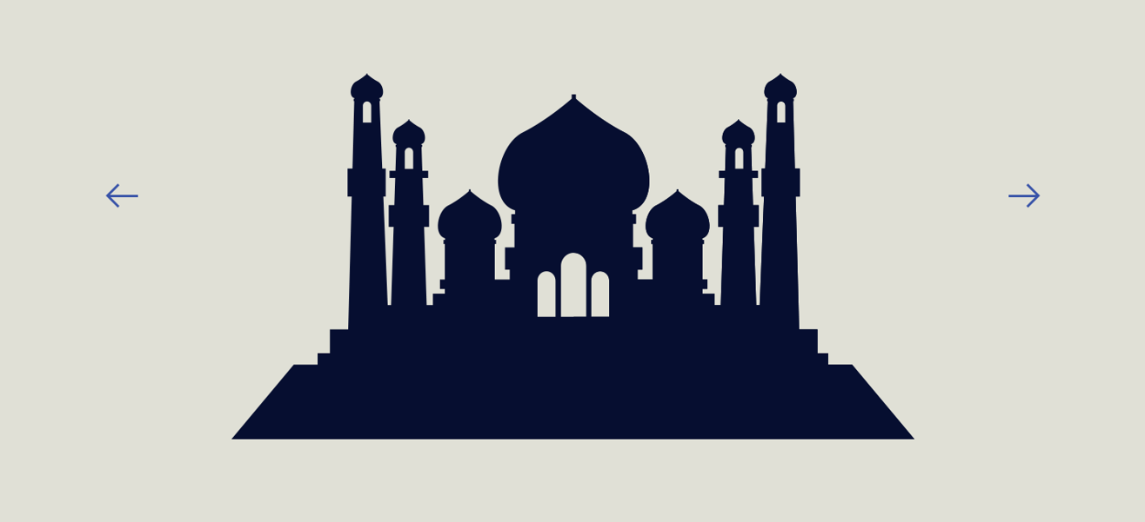

**Section 3: Small Banner. (This banner have two divs – left & Right).**

Time Allowed: 10 Minutes.

Total Marks: 5



**Section 4: Cards**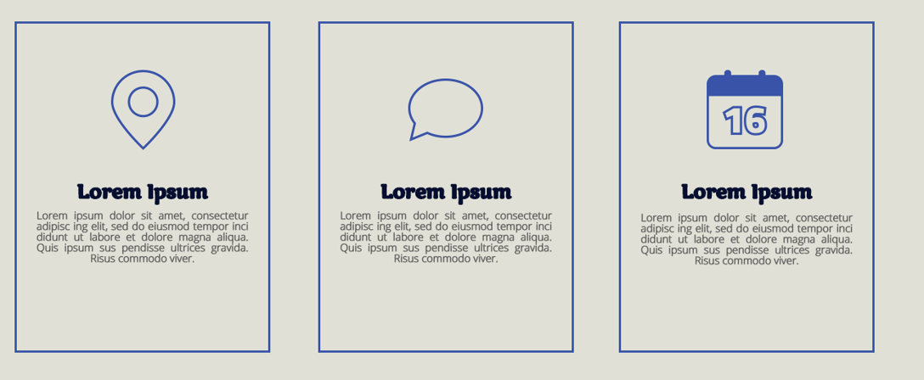

Time Allowed: 10 Minutes.

Total Marks: 5

**Section 4: offers**

Time Allowed: 20 Minutes.

Total Marks: 10

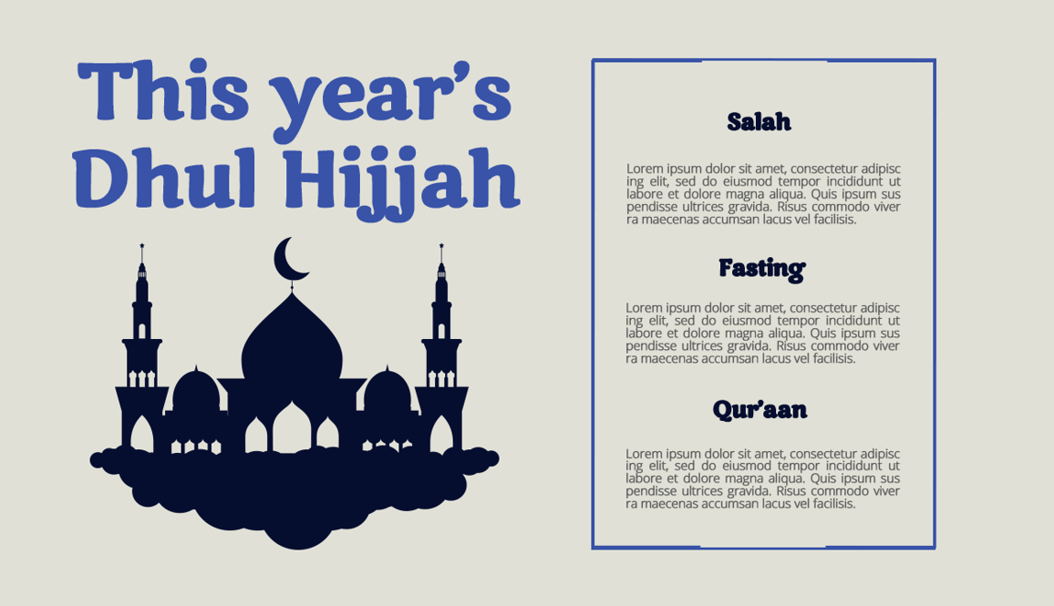

**Section 5: Form (Just make the form - no need to add RE).**

Time Allowed: 10 Minutes.

Total Marks: 10

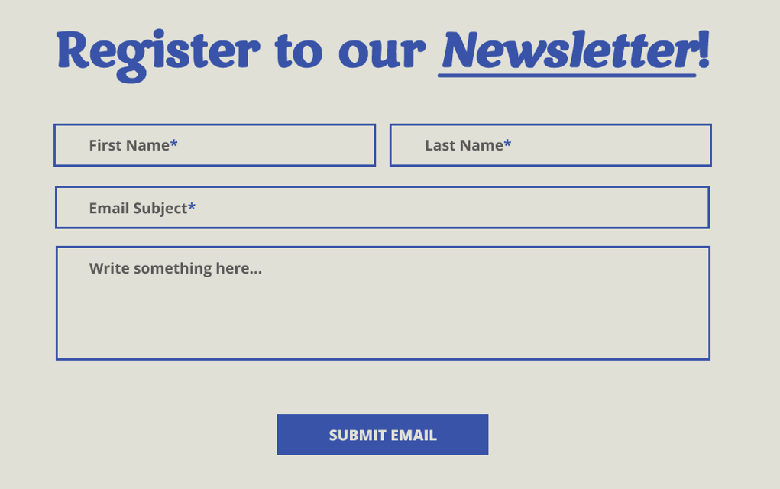

Time Allowed: 10 Minutes.

Total Marks: 10

**Section 6: Footer**

